Chapter 9: Managing Employee Performance

A Dilemma
You have been the store manager for a large coffee shop for three years but have never had this type of problem employee to handle before, and you schedule a meeting to speak with your HR manager about it. Jake, one of your best employees, has recently begun to have some problems. He is showing up to work late at least twice per week, and he missed the mandatory employee meeting on Saturday morning. When you ask him about it, he says that he is having some personal problems and will try to get better.
For a bit of time, Jake does get better, comes to work on time, and is his normal, pleasant self when helping customers. However, the situation gets more serious two weeks later when Jake comes to work smelling of alcohol and wearing the same clothes he wore to work the day before. You overhear some of the employees talking about Jake’s drinking problem. You pull Jake aside and ask him what is happening. He says his wife kicked him out of the house last night and he stayed with a friend, but he didn’t have time to gather any of his belongings when he left his house. You accept his answer and hope that things will get better.
A week later, when Jake arrives for his 10–7 shift, he is obviously drunk. He is talking and laughing loudly, smells of alcohol, and has a hard time standing up. You pull him aside and decide to have a serious talk with him. You confront him about his drinking problem, but he denies it, saying he isn’t drunk, just tired from everything happening with his wife. You point out the smell and the inability to stand up, and Jake starts crying and says he quit drinking ten years ago but has recently started again with his impending divorce. He begs for you to give him another chance and promises to stop drinking. You tell him you will think about it, but in the meantime, you send him home.
The meeting with HR is this afternoon and you feel nervous. You want to do what is right for Jake, but you also know this kind of disruptive behavior can’t continue. You like Jake as a person and he is normally a good employee, so you don’t want to fire him. When you meet with the HR manager, he discusses your options. The options, he says, are based on a discipline process developed by HR, and the process helps to ensure that the firing of an employee is both legal and fair. As you review the process, you realize that ignoring the behavior early on has an effect on what you can do now. Since you didn’t warn Jake earlier, you must formally document his behavior before you can make any decision to let him go. You hope that Jake can improve so it doesn’t come down to that.

9.1 Handling Performance

Learning Objectives
- Explain the types of performance issues that occur in the workplace, and the internal and external reasons for poor performance.
- Understand how to develop a process for handling employee performance issues.
- Be able to discuss considerations for initiating layoffs or downsizing.
As you know from reading this book so far, the time and money investment in a new employee is overwhelming. The cost to select, hire, and train a new employee is staggering. But what if that new employee isn’t working out? This next section will provide some examples of performance issues and examples of processes to handle these types of employee problems.

Types of Performance Issues
One of the most difficult parts of managing others isn’t when they are doing a great job—it is when they aren’t doing a good job. In this section, we will address some examples of performance issues and how to handle them.
- Constantly late or leaves early. While we know that flexible schedules can provide a work-life balance, managing this flexible schedule is key. Some employees may take advantage and, instead of working at home, perform nonwork-related tasks instead.
- Too much time spent doing personal things at work. Most companies have a policy about using a computer or phone for personal use. For most companies, some personal use is fine, but it can become a problem if someone doesn’t know where to draw the line.
- Inability to handle proprietary information. Many companies handle important client and patient information. The ability to keep this information private for the protection of others is important to the success of the company.
- Family issues. Child-care issues, divorce, or other family challenges can cause absenteeism, but also poor work quality. Absenteeism is defined as a habitual pattern of not being at work.
- Drug and alcohol abuse. The US Department of Labor says that 40 percent of industrial fatalities and 47 percent of industrial injury can be tied to alcohol consumption. The US Department of Labor estimates that employees who use substances are 25–30 percent less productive and miss work three times more often than nonabusing employees. ^{[1]} Please keep in mind that when we talk about substance abuse, we are talking about not only illegal drugs but prescription drug abuse as well. In fact, the National Institute on Drug Abuse says that 15.2 million Americans have taken a prescription pain reliever, tranquilizer, or sedative for nonmedical purposes at least once. ^{[2]} Substance abuse can cause obvious problems, such as tardiness, absenteeism, and nonperformance, but it can also result in accidents or other more serious issues.
- Nonperforming. Sometimes employees are just not performing at their peak. Some causes may include family or personal issues, but oftentimes it can mean motivational issues or lack of tools and/or ability to do their current job.
- Conflicts with management or other employees. While it is normal to have the occasional conflict at work, some employees seem to have more than the average owing to personality issues. Of course, this affects an organization’s productivity.
- Theft. The numbers surrounding employee theft are staggering. The American Marketing Association estimates $10 billion is lost annually owing to employee theft, while the FBI estimates up to $150 billion annually. ^{[3]} Obviously, this is a serious employee problem that must be addressed.
- Ethical breaches. The most commonly reported ethical breaches by employees include lying, withholding information, abusive behavior, and misreporting time or hours worked, according to a National Business Ethics study. ^{[4]} Sharing certain proprietary information when it is against company policy and violating noncompete agreements are also considered ethical violations. Many companies also have a nonfraternization policy that restricts managers from socializing with nonmanagement employees.
- Harassment. Engagement of sexual harassment, bullying, or other types of harassment would be considered an issue to be dealt with immediately and, depending on the severity, may result in immediate termination.
- Employee conduct outside the workplace. Speaking poorly of the organization on blogs or Facebook is an example of conduct occurring outside the workplace that could violate company policy. Violating specific company policies outside work could also result in termination. For example, in 2010, thirteen Virgin Atlantic employees were fired after posting criticisms about customers and joking about the lack of safety on Virgin airplanes in a public Facebook group. ^{[5]}In another example, an NFL Indianapolis Colts cheerleader was fired after racy Playboy promotional photos surfaced (before she became a cheerleader) that showed her wearing only body paint. ^{[6]}
While certainly not exhaustive, this list provides some insight into the types of problems that may be experienced. As you can see, some of these problems are more serious than others. Some issues may only require a warning, while some may require immediate dismissal. As an HR professional, it is your job to develop policies and procedures for dealing with such problems. Let’s discuss these next.

Fortune 500 Focus
To handle attendance problems at many organizations, a no-fault attendance plan is put into place. In this type of plan, employees are allowed a certain number of absences; when they exceed that number, a progressive discipline process begins and might result in dismissal of the employee. A no-fault attendance policy means there are no excused or unexcused absences, and all absences count against an employee. For example, a company might give one point for an absence that is called in the night before work, a half point for a tardy, and two points for a no-call and no-show absence. When an employee reaches a certain number determined by the company, he or she is disciplined. This type of policy is advantageous in industries in which unplanned absences have a direct effect on productivity, such as manufacturing and production. Another advantage is that managers do not need to make judgment calls on what is an excused versus an unexcused absence, and this can result in fairness to all employees.
One such company with a no-fault attendance policy is Verizon Communications. However, the Equal Employment Opportunity Commission (EEOC) investigated this policy and announced that Verizon will pay $20 million to resolve a disability discrimination lawsuit. ^{[7]} The lawsuit said that the company, through use of the no-fault attendance policy, denied reasonable accommodations required by the Americans with Disabilities Act (ADA). As a result, hundreds of Verizon employees were disciplined or fired. In this case, the EEOC cites paid or unpaid leave as one way for an employer to provide reasonable accommodations for an employee with a disability. The policy specified there would be no exceptions made to the no-fault attendance policy to accommodate employees with ADA disabilities. When discussing the case, the EEOC chair justified the agency’s position by saying, “Flexibility on leave can enable a worker with a disability to remain employed and productive, a win for the worker, employer, and the economy. By contrast, an inflexible leave policy may deny workers with disabilities a reasonable accommodation.” ^{[8]} Part of the settlement also involved additional training to Verizon employees on ADA and how to administer the attendance plan. This successful lawsuit shows that even the most seemingly clear performance expectations must be flexible to meet legal obligations.

What Influences Performance?
When an employee isn’t performing as expected, it can be very disapointing. When you consider the amount of time it takes to recruit, hire, and train someone, it can be disappointing to find that a person has performance issues. Sometimes performance issues can be related to something personal, such as drug or alchol abuse, but often it is a combination of factors. Some of these factors can be internal while others may be external. Internal factors may include the following:
- Career goals are not being met with the job.
- There is conflict with other employees or the manager.
- The goals or expectations are not in line with the employee’s abilities.
- The employee views unfairness in the workplace.
- The employee manages time poorly.
- The employee is dissatisfied with the job.
Some of the external factors may include the following:
- The employee doesn’t have correct equipment or tools to perform the job.
- The job design is incorrect.
- External motivation factors are absent.
- There is a lack of management support.
- The employee’s skills and job are mismatched.
All the internal reasons speak to the importance once again of hiring the right person to begin with. The external reasons may be something that can be easily addressed and fixed. Whether the reason is internal or external, performance issues must be handled in a timely manner. This is addressed in Section 10.1.3 "Defining Discipline". We discuss performance issues in greater detail in Chapter 11 "Employee Assessment".

Defining Discipline
If an employee is not meeting the expectations, discipline might need to occur.Discipline is defined as the process that corrects undesirable behavior. The goal of a discipline process shouldn’t necessarily be to punish, but to help the employee meet performance expectations. Often supervisors choose not to apply discipline procedures because they have not documented past employee actions or did not want to take the time to handle the situation. When this occurs, the organization lacks consistency among managers, possibility resulting in motivational issues for other employees and loss of productivity.
To have an effective discipline process, rules and policies need to be in place and communicated so all employees know the expectations. Here are some guidelines on creation of rules and organizational policies:
- All rules or procedures should be in a written document.
- Rules should be related to safety and productivity of the organization.
- Rules should be written clearly, so no ambiguity occurs between different managers.
- Supervisors, managers, and human resources should communicate rules clearly in orientation, training, and via other methods.
- Rules should be revised periodically, as the organization’s needs change.
Of course, there is a balance between too many “rules” and giving employees freedom to do their work. However, the point of written rules is to maintain consistency. Suppose, for example, you have a manager in operations and a manager in marketing. They both lead with a different style; the operations manager has a more rigid management style, while the marketing manager uses more of a laissez-faire approach. Suppose one employee in each of the areas is constantly late to work. The marketing manager may not do anything about it, while the operations manager may decide each tardy day merits a “write-up,” and after three write-ups, the employee is let go. See how lack of consistency might be a problem? If this employee is let go, he or she might be able to successfully file a lawsuit for wrongful termination, since another employee with the same performance issue was not let go. Wrongful termination means an employer has fired or laid off an employee for illegal reasons, such as violation of antidiscrimination laws or violation of oral and/or written employee agreements. To avoid such situations, a consistent approach to managing employee performance is a crucial part of the human resources job.

The Role of the Performance Appraisal in Discipline
Besides the written rules, each individual job analysis should have rules and policies that apply to that specific job. We discuss performance appraisal in further detail in Chapter 10 "Employee Assessment", but it is worth a mention here as well. The performance appraisal is a systematic process to evaluate employees on (at least) an annual basis. The organization’s performance appraisal and general rules and policies should be the tools that measure the employee’s overall performance. If an employee breaks the rules or does not meet expectations of the performance appraisal, the performance issue model, which we will discuss next, can be used to correct the behavior.

Performance Issue Model
Because of the many varieties of performance issues, we will not discuss how to handle each type in detail here. Instead, we present a model that can be used to develop policies around performance, for fairness and consistency.
We can view performance issues in one of five areas. First, the mandated issue is serious and must be addressed immediately. Usually, the mandated issue is one that goes beyond the company and could be a law. Examples of mandated issues might include an employee sharing information that violates privacy laws, not following safety procedures, or engaging in sexual harassment. For example, let’s say a hospital employee posts something on his Facebook page that violates patient privacy. This would be considered a mandated issue (to not violate privacy laws) and could put the hospital in serious trouble. These types of issues need to be handled swiftly. A written policy detailing how this type of issue would be handled is crucial. In our example above, the policy may state that the employee is immediately fired for this type of violation. Or, it may mean this employee is required to go through privacy training again and is given a written warning. Whatever the result, developing a policy on how mandated issues will be handled is important for consistency.

Figure 9.1 The Process for Handling Performance Issues
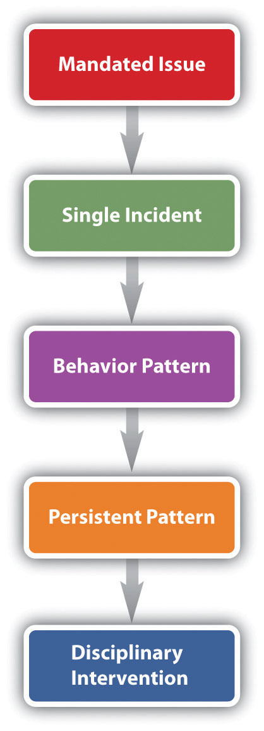

The second performance issue can be called a single incident. Perhaps the employee misspeaks and insults some colleagues or perhaps he or she was over budget or late on a project. These types of incidents are usually best solved with a casual conversation to let the employee know what he or she did wasn’t appropriate. Consider this type of misstep a development opportunity for your employee. Coaching and working with the employee on this issue can be the best way to nip this problem before it gets worse.

Often when single incidents are not immediately corrected, they can evolve into a behavior pattern, which is our third type of performance issue. This can occur when the employee doesn’t think the incident is a big deal because he hasn’t been correct before or may not even realize his is doing something wrong. In this case, it’s important to talk with the employee and let him know what is expected.
If the employee has been corrected for a behavior pattern but continues to exhibit the same behavior, we call this a persistent pattern. Often you see employees correct the problem after an initial discussion but then fall back into old habits. If they do not self-correct, it could be they do not have the training or the skills to perform the job. In this phase of handling performance issues, it is important to let the employee know that the problem is serious and further action will be taken if it continues. If you believe the employee just doesn’t have the skills or knowledge to perform the job, asking him or her about this could be helpful to getting to the root of the problem as well. If the employee continues to be nonperforming, you may consider utilizing the progressive discipline process before initiating an employee separation. However, investigating the performance issue should occur before implementing any sort of discipline.

Investigation of Performance Issues
When an employee is having a performance issue, often it is our responsibility as HR professionals to investigate the situation. Training managers on how to document performance failings is the first step in this process. Proper documentation is necessary should the employee need to be terminated later for the performance issue. The documentation should include the following information:
- Date of incident
- Time of incident
- Location (if applicable) of incident
- A description of the performance issue
- Notes on the discussion with the employee on the performance issue
- An improvement plan, if necessary
- Next steps, should the employee commit the same infraction
- Signatures from both the manager and employee
With this proper documentation, the employee and the manager will clearly know the next steps that will be taken should the employee commit the infraction in the future. Once the issue has been documented, the manager and employee should meet about the infraction. This type of meeting is called an investigative interview and is used to make sure the employee is fully aware of the discipline issue. This also allows the employee the opportunity to explain his or her side of the story. These types of meetings should always be conducted in private, never in the presence of other employees.
In unionized organizations, however, the employee is entitled to union representation at the investigative interview. This union representation is normally calledinterest based bargaining ^{[9]} referring to a National Labor Relations Board case that went to the United States Supreme Court in 1975. Recently, Weingarten rights continued to be protected when Alonso and Carus Ironworks was ordered to cease and desist from threatening union representatives who attempted to represent an employee during an investigative interview. ^{[10]}

Options for Handling Performance Issues
Our last phase of dealing with employee problems would be a disciplinary intervention. Often this is called the progressive discipline process. It refers to a series of steps taking corrective action on nonperformance issues. The progressive discipline process is useful if the offense is not serious and does not demand immediate dismissal, such as employee theft. The progressive discipline process should be documented and applied to all employees committing the same offenses. The steps in progressive discipline normally are the following:
- First offense: Unofficial verbal warning. Counseling and restatement of expectations.
- Second offense: Official written warning, documented in employee file.
- Third offense: Second official warning. Improvement plan (discussed later) may be developed. Documented in employee file.
- Fourth offense: Possible suspension or other punishment, documented in employee file.
- Fifth offense: Termination and/or alternative dispute resolution.

University of Iowa’s Progressive Discipline Process
The chart below shows the typical progressive discipline process at the University of Iowa:

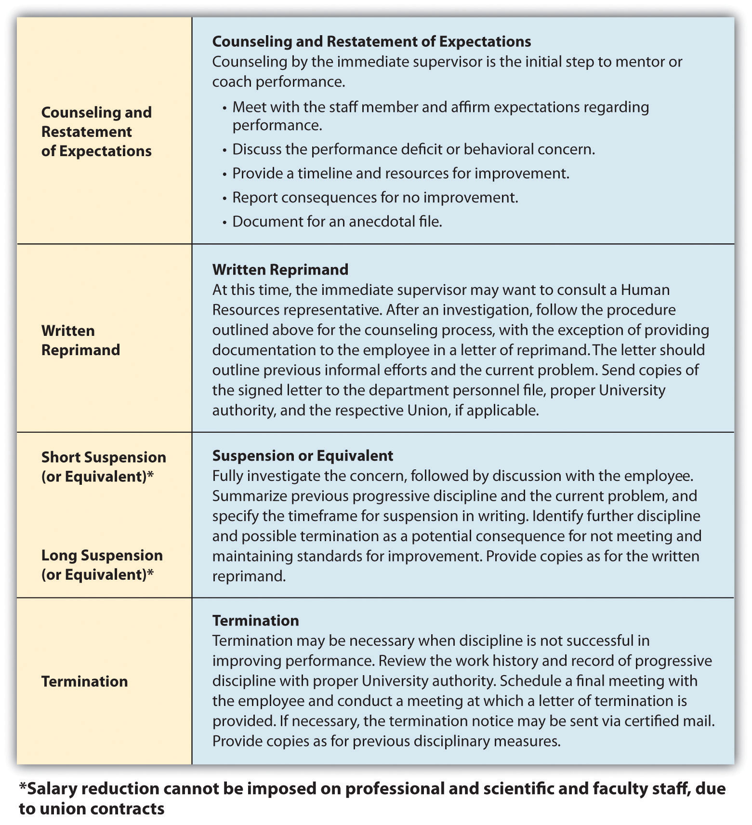
The Seven Tests of Just Cause
The seven test[s] of just cause represent a practical and effective way to determine whether a proposed disciplinary action is firmly and fairly grounded. It is fair to assume that these tests will be applied by arbitrators in the event that disciplinary actions are challenged, and it is therefore good practice to apply them prospectively when considering the imposition of progressive discipline.
Seven tests:
- Notice
  - Prior to imposition of discipline, employee must have notice of rules and expectations.
  - Establish through:
    - New employee orientation
      - Orientation checklists
      - Receipts for departmental handbooks
  - Periodic reinforcement/coaching
- Reasonable Rules and Orders
  - Cannot be inconsistent with collective bargaining agreement(s)
  - Cannot be arbitrary or capricious
  - Must be reasonably related to business necessity
- Investigation
  - Must be thorough; consider all evidence, pro and con.
  - Must be timely:
    - Should be completed expeditiously
    - Occurs before discipline imposed
  - Give accused opportunity to respond (Loudermill hearing).
  - Allow union representation (Weingarten rights).
- Fair Investigation
  - Result must not be forgone conclusion.
  - Test assumptions/bias.
- Proof
  - Level of proof is normally substantial evidence.
  - Greater proof required for more serious allegations.
- Equal Treatment
Equal treatment must be balanced against just application:
  - Rules must be applied even-handedly and without discrimination.
  - Rules must be applied justly.
  - Don’t blindly apply the same rule to all situations—managers/supervisors are expected to exercise judgment.
- Penalty
  - Must be fair, not arbitrary and capricious, or based on emotional response.
  - Factor in length of service, prior performance history, and previous progressive discipline.
Source: Reprinted from the University of Iowa’s Office of the Vice President for Research, http://research.uiowa.edu/pimgr/?get=discipline and http://research.uiowa.edu/pimgr/?get=7steps (accessed September 15, 2011).
Another option for handling continued infractions is to consider putting the employee on an improvement plan, which outlines the expectations and steps the employee should take to improve performance. We address this in greater detail in Chapter 10 "Employee Assessment". The plan is detailed and outlined and ensures both parties understand the specific expectations for improvement. If the improvement plan does not work, a progressive discipline process might be used.
Whichever direction is taken with disciplining of the employee, documentation is key throughout the process to avoid wrongful termination issues.

Figure 9.2 Sample of a Performance Improvement Plan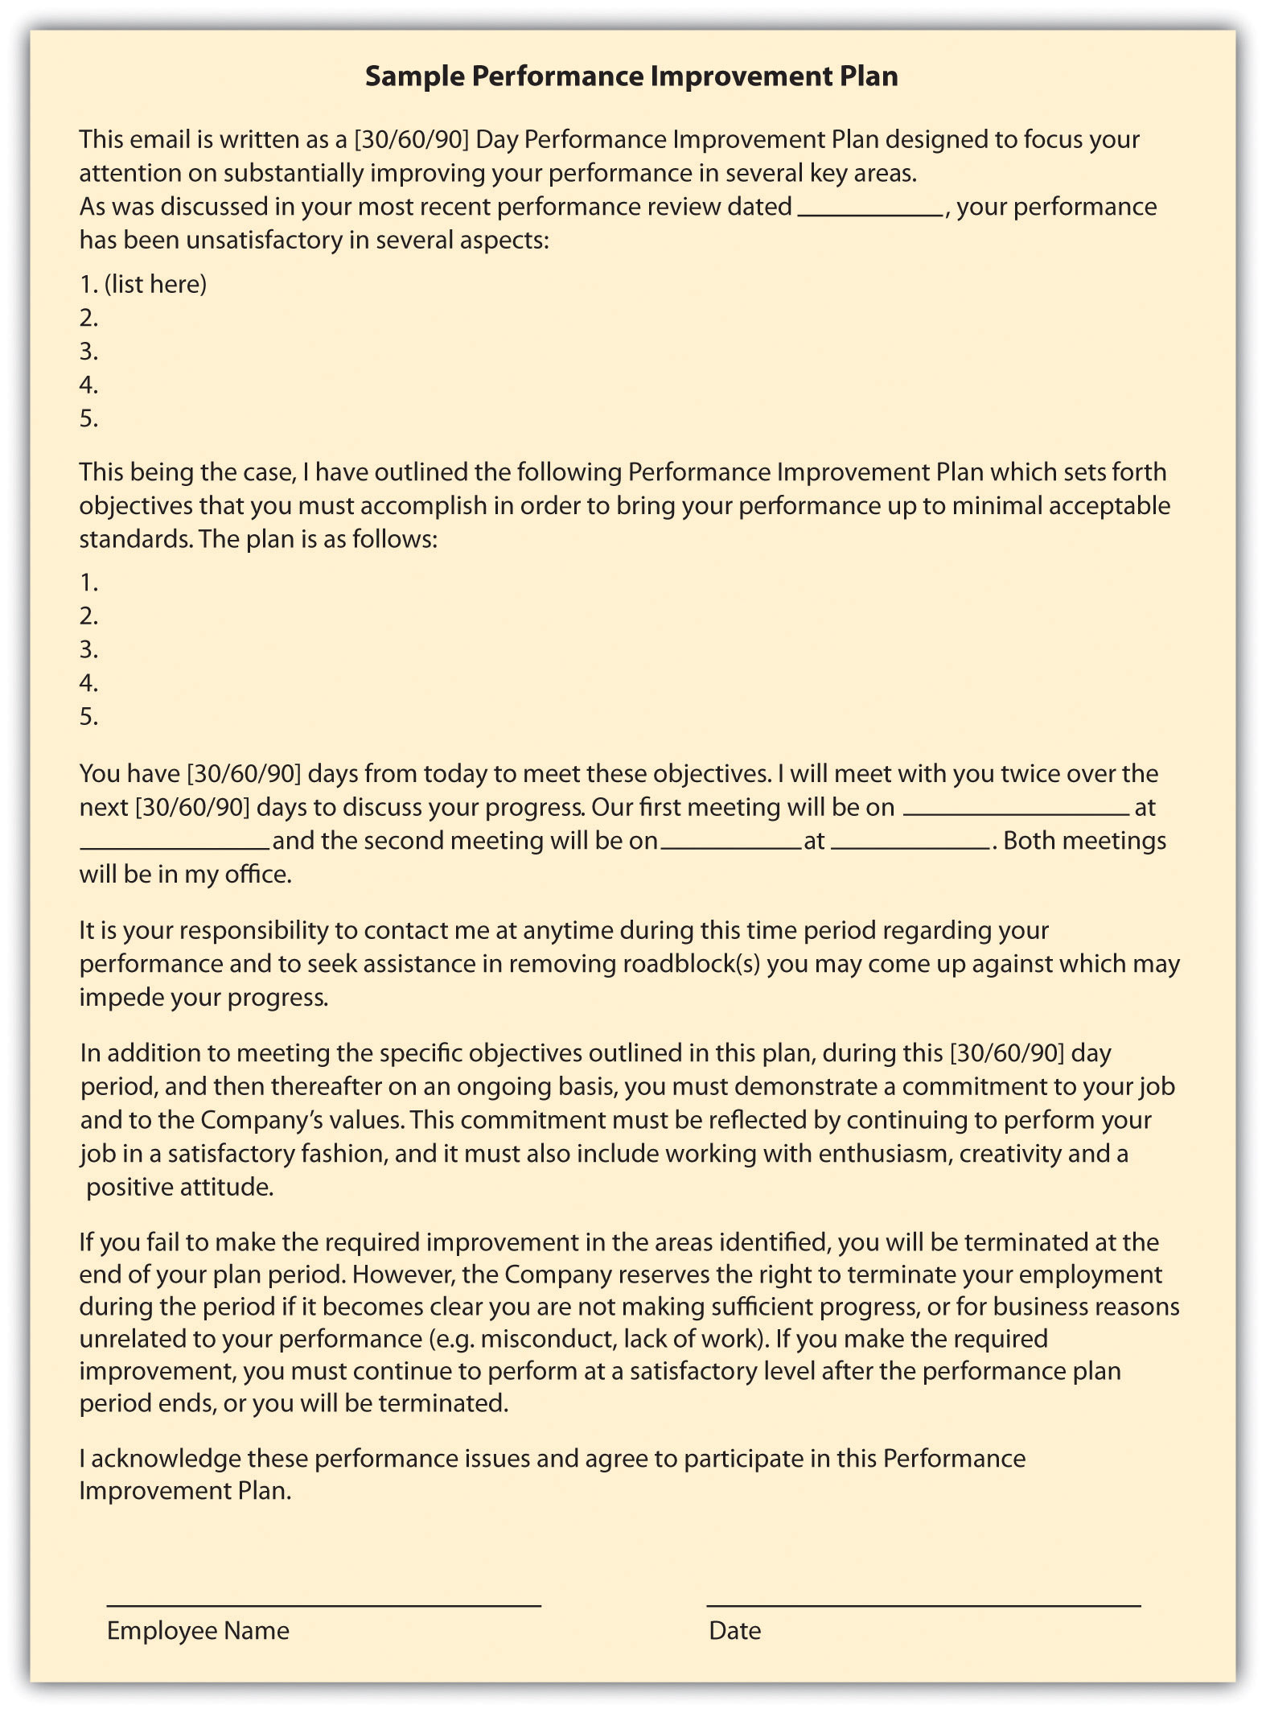

Alternative Dispute Resolution
Another option in handling disputes, performance issues, and terminations isalternative dispute resolution (ADR). This method can be effective in getting two parties to come to a resolution. In ADR, an unbiased third party looks at the facts in the case and tries to help the parties come to an agreement. In mediation, the third party facilitates the resolution process, but the results of the process are not binding for either party. This is different from arbitration, in which a person reviews the case and makes a resolution or a decision on the situation. The benefits of ADR are lower cost and flexibility, as opposed to taking the issue to court. We discuss these types of systems in greater detail in Chapter 12 "Working with Labor Unions".
Some organizations use a step-review system. In this type of system, the performance issue is reviewed by consecutively higher levels of management, should there be disagreement by the employee in a discipline procedure. Some organizations also implement a peer resolution system. In this type of system, a committee of management and employees is formed to review employee complaints or discipline issues. In this situation, the peer review system normally involves the peer group reviewing the documentation and rendering a decision. Another type of ADR is called the ombudsman system. In this system, a person is selected (or elected) to be the designated individual for employees to go to should they have a complaint or an issue with a discipline procedure. In this situation, the ombudsman utilizes problem-solving approaches to resolve the issue. For example, at National Geographic Traveler Magazine an ombudsman handles employee complaints and issues and also customer complaints about travel companies.

Employee Separation
Employee separation can occur in any of these scenarios. First, the employee resigns and decides to leave the organization. Second, the employee is terminated for one or more of the performance issues listed previously. Lastly, absconding is when the employee decides to leave the organization without resigning and following the normal process. For example, if an employee simply stops showing up to work without notifying anyone of his or her departure, this would be considered absconding. Let’s discuss each of these in detail. Employee separation costs can be expensive, as we learned in Chapter 7 "Retention and Motivation".In the second quarter in 2011, for example, Halliburton reported $8 million in employee separation costs. ^{[11]}
Resignation means the employee chooses to leave the organization. First, if an employee resigns, normally he or she will provide the manager with a formal resignation e-mail. Then the HR professional usually schedules an exit interview, which can consist of an informal confidential discussion as to why the employee is leaving the organization. If HR thinks the issue or reasons for leaving can be fixed, he or she may discuss with the manager if the resignation will be accepted. Assuming the resignation is accepted, the employee will work with the manager to determine a plan for his or her workload. Some managers may prefer the employee leave right away and will redistribute the workload. For some jobs, it may make sense for the employee to finish the current project and then depart. This will vary from job to job, but two weeks’ notice is normally the standard time for resignations.
If it is determined an employee should be terminated, different steps would be taken than in a resignation. First, documentation is necessary, which should have occurred in the progressive discipline process. Performance appraisals, performance improvement plans, and any other performance warnings the employee received should be readily available before meeting with the employee. It should be noted that the reliability and validity of performance appraisals should be checked before dismissing an employee based upon them. Questionable performance appraisals come from the real-world conditions common to rating situations, particularly because of limitations in the abilities of the raters. ^{[12]} Reliability and validity of performance appraisals are discussed in detail in Chapter 10 "Employee Assessment".
Remember that if the discipline process is followed as outlined prior, a termination for nonperformance should never be a surprise to an employee. Normally, the manager and HR manager would meet with the employee to deliver the news. It should be delivered with compassion but be direct and to the point. Depending on previous contracts, the employee may be entitled to a severance package. A severance package can include pay, benefits, or other compensation for which an employee is entitled when they leave the organization. The purpose of a severance plan is to assist the employee while he or she seeks other employment. The HR professional normally develops this type of package in conjunction with the manager. Some considerations in developing a severance package (preferably before anyone is terminated) might include the following:
- How the severance will be paid (i.e., lump sum or in x equal increments)
- Which situations will pay a severance and which will not. For example, if an employee is terminated for violation of a sexual harassment policy, is a severance still paid?
- A formula for how severance will be paid, based on work group, years with the organization, etc.
- Legal documents, such as legal releases and noncompete agreements
- How accrued vacation and/or sick leave will be paid, if at all
The last topic that we should discuss in this section is the case of an absconded employee. If an employee stops showing up to work, a good effort to contact this person should be the first priority. If after three days this person has not been reachable and has not contacted the company, it would be prudent to stop pay and seek legal help to recover any company items he or she has, such as laptops or parking passes.
Sometimes rather than dealing with individual performance issues and/or terminations, we find ourselves having to perform layoffs of several to hundreds of employees. Let’s address your role in this process next.

Rightsizing and Layoffs
Rightsizing refers to the process of reducing the total size of employees, to ultimately save on costs. Downsizing ultimately means the same thing as rightsizing, but the usage of the word has changed in that rightsizing seems to define the organization’s goals better, which would be to reduce staff to save money, or rightsize. When a company decides to rightsize and, ultimately, engage in layoffs, some aspects should be considered.
First, is the downturn temporary? There is nothing worse than laying people off, only to find that as business increases, you need to hire again. Second, has the organization looked at other ways to cut expenses? Perhaps cutting expenses in other areas would be advisable before choosing to lay people off. Finally, consideration should be given to offering temporary sabbaticals, voluntary retirement, or changing from a full- to part-time position. Some employees may even be willing to take a temporary pay cut to reduce costs. Organizations find they can still keep good people by looking at some alternatives that may work for the employee and the organization, even on a temporary basis.
If the company has decided the only way to reduce costs is to cut full-time employees, this is often where HR should be directly involved to ensure legal and ethical guidelines are met. Articulating the reasons for layoffs and establishing a formalized approach to layoffs is the first consideration. Before it is decided who should get cut, criteria should be developed on how these decisions will be made. Similar to how selection criteria might be developed, the development of criteria that determines which jobs will be cut makes the process of cutting more fair, albeit still difficult. Establishing the criteria ahead of time can also help avoid managers’ trying to “save” certain people from their own departments. After development of criteria, the next phase would be to sit down with management and decide who does or doesn’t meet the criteria and who will be laid off. At this point, before the layoffs happen, it makes sense to discuss severance packages. Usually, when an employee signs for a severance package, the employee should also sign a form (the legal department can help with this) that releases the organization from all future claims made by the employee.
After criteria have been developed, people selected, and severance packages determined, it’s key to have a solid communication plan as to how the layoffs will be announced. Usually, this involve an initial e-mail to all employees, letting them know of impending layoffs. Speak with each employee separately, then announce which positions were eliminated. The important thing to remember during layoffs is keeping your employees’ dignity; they did not do anything wrong to lose their job—it was just a result of circumstances.

[1] United States Department of Labor, “General Workplace Impact,” 2011, accessed March 8, 2011, http://www.esrcheck.com/wordpress/2011/08/12/studies-show-drugs-in-workplace-cost-employers-billions- and-small-businesses-employ-more-drug-users-but-drug-test-less/.
[2] Barry Fisher, “Targeting Prescription Drug Abuse,” Ventura County Star, March 6, 2011, accessed March 8, 2011, http://www.vcstar.com/news/2011/mar/06/targeting-prescription-drug-abuse/.
[3] “Employee Theft and Legal Aspects,” Net Industries, accessed March 8, 2011,http://law.jrank.org/pages/1084/Employee-Theft-Legal-Aspects-Estimates-cost.html.
[4] “Careers By the Numbers,” InfoWorld, October 2, 2000, accessed August 1, 2011,http://books.google.com/books?id=ST0EAAAAMBAJ&pg=PA93&lpg=PA93&dq=Careers+By+the+Numbers +InfoWorld+October+2,+2000&source=bl&ots=KU2eMTa3C3&sig=rU3s8ywYcc0Z kUbuydMO3wrO1Rc&hl=en&sa=X&ei=yoVsT6PfGYSw0QH11u3TBg&ved=0CCIQ6 AEwAA#v=onepage&q= Careers%20By%20the%20Numbers%20InfoWorld%20October %202%2C%202000&f=false.
[5] Catherine Smith, “Fired Over Facebook,” Huffington Post, July 2010, accessed August 1, 2011, http://www.huffingtonpost.com/2010/07/26/fired-over-facebook-posts_n_659170.html#s115752&title=13_Virgin_Atlantic.
[6] Rick Chandler, “Ex-Colts Cheerleader Sues Team Over Dismissal for Playboy Pics,” NBC Sports, May 11, 2011, accessed August 1, 2011,http://offthebench.nbcsports.com/2011/05/11/ex-colts-cheerleader-sues-team-over-dismissal-for-playboy-pics/.
[7] Jim Evans, “EEOC Finds Fault with Company’s No Fault Attendance Plan,” Zanesville Times, July 17, 2011, accessed August 1, 2011,http://www.businessmanagementdaily.com/19860/eeoc-finds-fault-with-no-fault-attendance-policies.
[8] Jim Evans, “EEOC Finds Fault with Company’s No Fault Attendance Plan,” Zanesville Times, July 17, 2011, accessed August 1, 2011,http://www.businessmanagementdaily.com/19860/eeoc-finds-fault-with-no-fault-attendance-policies.
[9] National Labor Relations Board website, “Administrative Law Judge Orders San Juan Company to Respect Employee Weingarten Rights,” March 28, 2011, accessed August 17, 2011.
[10] National Labor Relations Board website, “Administrative Law Judge Orders San Juan Company to Respect Employee Weingarten Rights,” March 28, 2011, accessed August 17, 2011.
[11] Brad Lemaire, “Halliburton Posts 54% Q2 Growth,” Proactive Investors, July 18, 2011, accessed August 1, 2011,http://www.proactiveinvestors.com/companies/news/16404/halliburton-posts-54-q2-profit-growth-16404.html.
[12] Jeff Weekley, Academy of Management Journal 32, no. 1 (1989): 213–22.

9.2 Employee Rights

Learning Objectives
- Be able to explain employee rights.
- Define unions and explain their relation to the HRM function.
Employee rights is defined as the ability to receive fair treatment from employers. This section will discuss employee rights surrounding job protection, privacy, and unionization.

Job Protection Rights
If HR doesn’t understand or properly manage employee rights, lawsuits are sure to follow. It is the HR professional’s job to understand and protect the rights of employees. In the United States, the employment-at-will principle (EAW) is the right of an employer to fire an employee or an employee to leave an organization at any time, without any specific cause. The EAW principle gives both the employee and employer freedom to terminate the relationship at any time. There are three main exceptions to this principle, and whether they are accepted is up to the various states:
- Public policy exception. With a public policy exception, an employer may not fire an employee if it would violate the individual state’s doctrine or statute. For example, in Borse v. Piece Goods Shop in Pennsylvania, a federal circuit court of appeals ruled that Pennsylvania law may protect at-will employees from being fired for refusing to take part in drug test programs if the employee’s privacy is invaded. Borse contended that the free speech provisions of the state and of the First Amendment protected the refusal to participate. Some public policy exceptions occur when an employee is fired for refusing to violate state or federal law.
- Implied contract exception. In a breach of an implied contract, the discharged employee can prove that the employer indicated that the employee has job security. The indication does not need to be formally written, only implied. InWright v. Honda, an Ohio employee was terminated but argued that the implied contract exception was relevant to the employment-at-will doctrine. She was able to prove that in orientation, Honda stressed to employees the importance of attendance and quality work. She was also able to prove that the language in the associate handbook implied job security: “the job security of each employee depends upon doing your best on your job with the spirit of cooperation.” Progress reports showing professional development further solidified her case, as she had an implied contract that Honda had altered the employment-at-will doctrine through its policies and actions.
- Good faith and fair dealing exception. In thegood faith and fair dealing exception, the discharged employee contends that he was not treated fairly. This exception to the employment-at-will doctrine is less common than the first two. Examples might include firing or transferring of employees to prevent them from collecting commissions, misleading employees about promotions and pay increases, and taking extreme actions that would force the employee to quit.
Table 9.1 State’s Acceptance of Employment-at-Will Exceptions
State | Public-Policy Exception | Implied-Contract Exception | Good Faith and Fair Dealing Exception
Alabama | no | yes | yes
Alaska | yes | yes | yes
Arizona | yes | yes | yes
Arkansas | yes | yes | no
California | yes | yes | yes
Colorado | yes | yes | no
Connecticut | yes | yes | no
Delaware | yes | no | yes
District of Columbia | yes | yes | no
Florida | no | no | no
Georgia | no | no | no
Hawaii | yes | yes | no
Idaho | yes | yes | yes
Illinois | yes | yes | no
Indiana | yes | no | no
Iowa | yes | yes | no
Kansas | yes | yes | no
Kentucky | yes | yes | no
Louisiana | no | no | no
Maine | no | yes | no
Maryland | yes | yes | no
Massachusetts | yes | no | yes
Michigan | yes | yes | no
Minnesota | yes | yes | no
Mississippi | yes | yes | no
Missouri | yes | no | no
Montana | yes | no | no
Nebraska | no | yes | no
Nevada | yes | yes | yes
New Hampshire | yes | yes | no
New Jersey | yes | yes | no
New Mexico | yes | yes | no
New York | no | yes | no
North Carolina | yes | no | no
North Dakota | yes | yes | no
Ohio | yes | yes | no
Oklahoma | yes | yes | no
Oregon | yes | yes | no
Pennsylvania | yes | no | no
Rhode Island | no | no | no
South Carolina | yes | yes | No
South Dakota | yes | yes | no
Tennessee | yes | yes | no
Texas | yes | no | no
Utah | yes | yes | yes
Vermont | yes | yes | no
Virginia | yes | no | no
Washington | yes | yes | no
West Virginia | yes | yes | no
Wisconsin | yes | yes | no
Wyoming | yes | yes | yes
Bold text indicates a state with all three exceptions.
Italic text indicates a state with none of the three exceptions.
When one of the exceptions can be proven, wrongful discharge accusations may occur. The United States is one of the few major industrial powers that utilize an employment-at-will philosophy. Most countries, including France and the UK, require employers to show just cause for termination of a person’s employment. ^{[1]} The advantage of employment at will allows for freedom of employment; the possibility of wrongful discharge tells us that we must be prepared to defend the termination of an employee, as to not be charged with a wrongful discharge case.
Employees also have job protection if they engage in whistleblowing.Whistleblowing refers to an employee’s telling the public about ethical or legal violations of his or her organization. This protection was granted in 1989 and extended through the Sarbanes-Oxley Act of 2002. Many organizations create whistleblowing policies and a mechanism to report illegal or unethical practices within the organization. ^{[2]}
Another consideration for employee job protection is that of an implied contract. It is in the best interest of HR professionals and managers alike to avoid implying an employee has a contract with the organization. In fact, many organizations develop employment-at-will policies and ask their employees to sign these policies as a disclaimer for the organization.
A constructive discharge means the employee resigned, but only because the work conditions were so intolerable that he or she had no choice. For example, if James is being sexually harassed at work, and it is so bad he quits, he would need to prove not only the sexual harassment but that it was so bad it required him to quit. This type of situation is important to note; should James’s case go to court and sexual harassment and constructive discharge are found, James may be entitled to back pay and other compensation.
The Worker Adjustment and Retraining Notification Act (WARN) requires organizations with more than one hundred employees to give employees and their communities at least sixty days’ notice of closure or layoff affecting fifty or more full-time employees. This law does not apply in the case of unforeseeable business circumstances. If an employer violates this law, it can be subject to back pay for employees. ^{[3]} This does not include workers who have been with the organization for less than six months, however.
Retaliatory discharge means punishment of an employee for engaging in a protected activity, such as filing a discrimination charge or opposing illegal employer practices. For example, it might include poor treatment of an employee because he or she filed a workers’ compensation claim. Employees should not be harassed or mistreated should they file a claim against the organization.

Privacy Rights
Technology makes it possible to more easily monitor aspects of employees’ jobs, although a policy on this subject should be considered before implementing it. In regard to privacy, a question exists whether an employer should be allowed to monitor an employee’s online activities. This may include work e-mail, websites visited using company property, and also personal activity online.
Digital Footprints, Inc. is a company that specializes in tracking the digital movements of employees and can provide reports to the organization by tracking these footprints. This type of technology might look for patterns, word usage, and other communication patterns between individuals. This monitoring can be useful in determining violations of workplace policies, such as sexual harassment. This type of software and management can be expensive, so before launching it, it’s imperative to address its value in the workplace.
Another privacy concern can include monitoring of employee postings on external websites. Companies such as Social Sentry, under contract, monitor employee postings on sites such as Facebook, Twitter, LinkedIn, and YouTube. ^{[4]} Lawyers warn, however, that this type of monitoring should only be done if the employee has consented. ^{[5]} A monitoring company isn’t always needed to monitor employees’ movements on social networking. And sometimes employees don’t even have to tweet something negative about their own company to lose their job. A case in point is when Chadd Scott, who does Atlanta sports updates for 680/The Fan, was fired for tweeting about Delta Airlines. In his tweet, he complained about a Delta delay and said they did not have enough de-icing fluid. Within a few hours, he was fired from his job, because Delta was a sponsor of 680/The Fan. ^{[6]}
The US Patriot Act also includes caveats to privacy when investigating possible terrorist activity. The Patriot Act requires organizations to provide private employee information when requested. Overall, it is a good idea to have a clear company policy and perhaps even a signed waiver from employees stating they understand their activities may be monitored and information shared with the US government under the Patriot Act.
Depending on the state in which you live, employees may be given to see their personnel files and the right to see and correct any incorrect information within their files. Medical or disability information should be kept separate from the employee’s work file, per the Americans with Disabilities Act. In addition, the Health Insurance Portability and Accountability Act (HIPAA) mandates that health information should be private, and therefore it is good practice to keep health information in a separate file as well.
Finally, drug testing and the right to privacy is a delicate balancing act. Organizations that implement drug testing often do so for insurance or safety reasons. Because of theDrug-Free Workplace Act of 1988, some federal contractors and all federal grantees must agree they will provide a drug-free workplace, as a condition of obtaining the contract. The ADA does not view testing for illegal drug use as a medical examination (making them legal), and people using illegal drugs are not protected under the ADA; ^{[7]} however, people covered under ADA laws are allowed to take medications directly related to their disability. In a recent case, Bates v. Dura Automotive Systems, an auto parts manufacturer had a high accident rate and decided to implement drug testing to increase safety. Several prescription drugs were banned because they were known to cause impairment. The plaintiffs in the case had been dismissed from their jobs because of prescription drug use, and they sued, claiming the drug-testing program violated ADA laws. ^{[8]} However, the Sixth Circuit Court reversed the case because the plaintiffs were not protected under ADA laws (they did not have a documented disability).
In organizations where heavy machinery is operated, a monthly drug test may be a job requirement. In fact, under the Omnibus Transportation Employee Testing Act of 1991, employers are legally required to test for drugs in transportation-related businesses such as airlines, railroads, trucking, and public

transportation, such as bus systems. Medical marijuana is a relatively new issue that is still being addressed in states that allow its use. For example, if the company requires a drug test and the employee shows positive for marijuana use, does asking the employee to prove it is being used for medical purposes
violate HIPAA privacy laws? This issue is certainly one to watch over the coming years.

Labor Unions
A union is an organization of employees formed to bargain with an employer. We discuss labor unions in greater detail in Chapter 11 "Working with Labor Unions". It is important to mention unions here, since labor contracts often guide the process for layoffs and discipline. Labor unions have been a part of the US workplace landscape since the late 1920s, but the Wagner Act of 1935 significantly impacted labor and management relations by addressing several unfair labor practices. The National Labor Relations Board is responsible for administering and enforcing the provisions outlined in the Wagner Act. The act made acts such as interfering with the formation of unions and discriminating on the basis of union membership illegal for employers. By the 1940s, 9 million people were members of a union, which spurred the passage of the Taft-Hartley Act. This act set a new set of standards for fair practices by the unions, within a unionized environment.
The purpose of a union is to give collective bargaining power to a group of individuals. For example, instead of one person negotiating salary, a union gives people the power to bargain as a group, creating a shift from the traditional power model. Issues to negotiate can include pay, health benefits, working hours, and other aspects relating to a job. People often decide to form a union if they perceive the organization or management of the organization is treating them unfairly. Some people also believe that belonging to a union means higher wages and better benefits.
Many employers feel it is not in the best interest of the organization to unionize, so they will engage in strategies to prevent unionization. This is discussed further in Chapter 11 "Working with Labor Unions". However, the Taft-Hartley Act says that employers can express their views about unions but may not threaten employees with loss of job or other benefits if they unionize. Some of the talking points an organization might express about unions include the following:
- Less ability to deal more informally with the organization
- Possibility of strikes
- Payment of union dues by employees
- Emphasis on what positive aspects the employer has provided
If employees still unionize, managers and HR professionals alike will engage in the bargaining process. The collective bargaining process is the process of negotiating an agreement between management and employees. This process ultimately defines the contract terms for employees. In negotiating with the union, being prepared is important. Gathering data of what worked with the old contract and what didn’t can be a good starting point. Understanding the union’s likely requests and preparing a counteraction to these requests and possible compromises should be done before even sitting down to the bargaining table. One of the better strategies for negotiating a contract is called interest-based bargaining. In this type of bargaining, mutual interests are brought up and discussed, rather than each party coming to the table with a list of demands. This can create a win-win situation for both parties.
Once an agreement has been decided, the union members vote whether to accept the new contract. If the contract is accepted, the next task is to look at how to administer the agreement.
First, the HR professional must know the contract well to administer it well. For example, if higher pay is successfully negotiated, obviously it would be the job of HR to implement this new pay scale. The HR professional may need to develop new sets of policies and procedures when a new agreement is in place. One such procedure HR may have to work with occasionally is the grievance process. As we will discuss in Chapter 11 "Working with Labor Unions", the grievance process is a formal way by which employees can submit a complaint regarding something that is not administered correctly in the contract. Usually, the grievance process will involve discussions with direct supervisors first, discussions with the union representative next, and then the filing of a formal, written grievance complaint. Management is then required to provide a written response to the grievance, and depending on the collective bargaining agreement, a formalized process is stated on how the appeals process would work, should the grievance not be solved by the management response. One such example is the dismissal of members of the National Air Traffic Controller Association (union). In 2011, of the 140 proposed dismissals of air traffic controllers, 58 had penalties rescinded, reduced, or deferred. ^{[9]} This is because of due-process protections used to prevent mass firings when a new administration comes to power. Federal workers, including controllers, can challenge disciplinary action penalties through a government panel called the Merit Systems Protection Board. The process is described in union contracts and mentions involvement of an arbitrator, if necessary.

[1] USLegal, “Employment at Will,” accessed March 15, 2011,http://employment.uslegal.com/employment-at-will/.
[2] Lilanthi Ravishankar, “Encouraging Internal Whistle Blowing,” Santa Clara University, accessed March 15, 2011,http://www.scu.edu/ethics/publications/submitted/whistleblowing.html.
[3] US Department of Labor, “WARN Fact Sheet,” accessed March 15, 2011,http://www.doleta.gov/programs/factsht/warn.htm.
[4] Teneros Corporation, “Social Sentry Lets Employers Track Their Workers across the Internet,” accessed March 17, 2011,http://www.readwriteweb.com/archives/social_sentry_track_employees_across_the_web.php.
[5] People Management, “Employers Should Have Monitoring Policy for Social Networks,” accessed March 17, 2011,http://www.peoplemanagement.co.uk/pm/articles/2011/02/employers-should-have-monitoring-policy-for-social-networks.htm.
[6] Rodney Ho, “Chadd Scott Said He Was Fired for Tweets about Delta,” Access Atlanta (blog), accessed March 16, 2011, http://blogs.ajc.com/radio-tv-talk/2011/03/15/680the-fans-chadd-scott-said-he-was-fired-for-tweets-about-delta-airlines/?cxntlid=thbz_hm.
[7] US Equal Employment Opportunity Commission, “The ADA, Your Responsibilities as an Employer,” accessed August 1, 2011, http://www.eeoc.gov/facts/ada17.html.
[8] Jackson lewis, “Employees’ ADA Claims on Prescription-Drug-Use Dismissals Rejected by Federal Court,” December 1, 2010, accessed August 1, 2011,http://www.jacksonlewis.com/resources.php?NewsID=3478.
[9] John Hughes, “You’re Fired Doesn’t Mean Fired to Four of 10 Air Traffic Controllers,”Bloomberg News, July 24, 2011, accessed August 1, 2011,http://www.bloomberg.com/news/2011-07-25/-you-re-fired-doesn-t-mean-fired-to-four-of-10-air-controllers.html.

9.3 Case and Summary

Chapter Summary
- Performance issues in the workplace are common. Examples of performance issues include constant tardiness, too much time at work handling personal issues, mishandling of proprietary information, family issues, drug and alcohol problems, nonperformance, theft, and conflicts in the workplace.
- Employees choose to leave organizations for internal and external reasons. Some of these may include a mismatch of career goals, conflict, too high expectations, time-management issues, and a mismatch between job and skills.
- HR professionals should develop a set of policies that deal with performance issues in the workplace. The advantage to having such policies is that they can eliminate wrongful termination legal action.
- A mandated issue is usually one that deals with safety or legal issues that go beyond the workplace. An infringement of this type of issue requires immediate attention.
- A single incident may include a misstep of the employee, and the employee should immediately be spoken with about it, to ensure it doesn’t happen again.
- A behavior pattern occurs when an employee consistently exhibits a performance issue. This type of issue should be discussed with the employee and actions taken, such as providing more training, to ensure it does not continue. A persistent pattern occurs when an employee consistently exhibits a performance issue and does not improve, despite HR’s talking with him or her.
- At some point during the persistent pattern, disciplinary action will likely need to be taken. It is important to develop consistent procedures on how to record and handle disciplinary issues.
- Employee separation occurs in one of three ways. First, the employee resignsfrom the organization. Second, the employee is terminated for performance issues, and third, an employee absconds. Absconds means the employee abandons his or her job without submitting a formal resignation.
- In some cases, a severance package may be offered to the employee upon his or her departure from the organization.
- Rightsizing is a term used when an organization must cut costs through layoffs of employees. Development of criteria for layoffs, communication, and severance package discussion are all parts of this process.
- Employment at will means that an employer can separate from an employee without cause, and vice versa.
- Even though we have employment at will, a wrongful discharge can occur when there are violations of public policy, an employee has a contract with an employer, or an employer does something outside the boundaries of good faith.
- Whistleblowing is when an employee notifies organizations of illegal or unethical activity. Whistleblowers are protected from discharge due to their activity.
- A constructive discharge means the conditions are so poor that the employee has no choice but to leave the organization.
- The Worker Adjustment and Retraining Notification Act (WARN) is a law that requires companies of one hundred or more employees to notify employees and the community if fifty or more employees are to be laid off.
- A retaliatory discharge is one that occurs if an employer fires or lays off an employee because of a charge the employee filed. For example, if an employee files a workers’ compensation claim and then is let go, this could be a retaliatory discharge.
- The privacy of employees is an issue that HR must address. It is prudent to develop policies surrounding what type of monitoring may occur within an organization. For example, some organizations monitor e-mail, computer usage, and even postings on social network sites.
- Drug testing is also a privacy issue, although in many industries requiring safe working conditions, drug testing can be necessary to ensure the safety of all employees.
- A union is a group of workers who decide to work together toward a collective bargaining agreement. This agreement allows workers to negotiate as one, rather than as individuals.
- The Wagner Act, passed in 1935, addresses many issues related to workers’ unionization.
- The process of collective bargaining means to negotiate a contract between management and workers. HR is generally part of this process.
- Interest based bargaining occurs when mutual interests are discussed, rather than starting with a list of demands.
- Once an agreement is reached, HR is generally responsible for knowing the agreement and implementing any changes that should occur as a result of the agreement. One such example is understanding the grievance process.

Chapter Case
Who Goes, Who Stays?
The consulting firm you have worked for over the last year is having some financial troubles. The large contracts it once had are slowly going away, and as your company struggles to make payroll, it is clear that layoffs must occur. The sales staff has not been meeting the sales goals set for them, resulting in incorrect budgets.
It has been decided that at least three people in the sales department should be laid off. You create a spreadsheet with pertinent sales employee data:
Name | Title | Years with the company | Last overall rating on performance evaluation (1–5 scale, 5 being highest) | Last year’s sales goal met?
Deb Waters | Sales Manager | 1 | 3 | N/A as her position is managerial
Jeff Spirits | Account Manager | 5 | 3 | Yes, 1% over
Orlando Chang | Account Manager | 3 | 4 | Yes, 10% over goal
Jake Toolmeyer | Account Manager | 2 | 4 | No, 2% under goal
Audrey Barnes | Account Manager | 5 | 5 | Yes, 15% over goal
Kelly Andrews | Account Manager | 1 | 2 | No, 20% under goal
Amir Saied | Account Manager | 8 | 5 | Yes, 5% over goal
Winfrey Jones | Account Manager | 4 | 2 | No, 10% under goal
- Making reasonable assumptions, develop criteria for the layoffs in the sales department.
- Develop a plan as to how layoffs will be communicated with the individual as well as within the company.
- Discuss strategies to motivate those sales employees who stay with the organization.

